TYPE A NOTICE

OF

REFERENDUM ELECTION

**April 1, 2025**

NOTICE IS HEREBY GIVEN, that at an election to be held in the several towns, villages, cities, wards, and election districts of the State of Wisconsin, on Tuesday, April 1, 2025, the following questions will be submitted to a vote of the people pursuant to law:

**Question 1:** “***Photographic identification for voting***. Shall section 1m of article III of the constitution be created to require that voters present valid photographic identification verifying their identity in order to vote in any election, subject to exceptions which may be established by law?”

This referendum ballot is a result of 2025 Senate Joint Resolution 2, a copy of which can be viewed or downloaded on the Legislature’s website at <https://docs.legis.wisconsin.gov/2025/proposals/reg/sen/joint_resolution/sjr2>.

A copy also can be obtained from the office of the county clerk, or the Legislative Documents Room at 1 East Main Street, Madison, Wisconsin.

DONE in the City of Monroe

this 16th day of January, 2025.

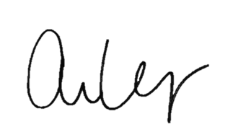

________________________________________________

Arianna L. Voegeli, Green County Clerk